SEND Information Report 2025/2026

Aims
Our SEND Information Report aims to:
- set out how our school will support and make provision for children and young people (CYP) with special educational needs and disabilities (SEND)
- explain the roles and responsibilities of everyone involved in providing for CYP with SEND

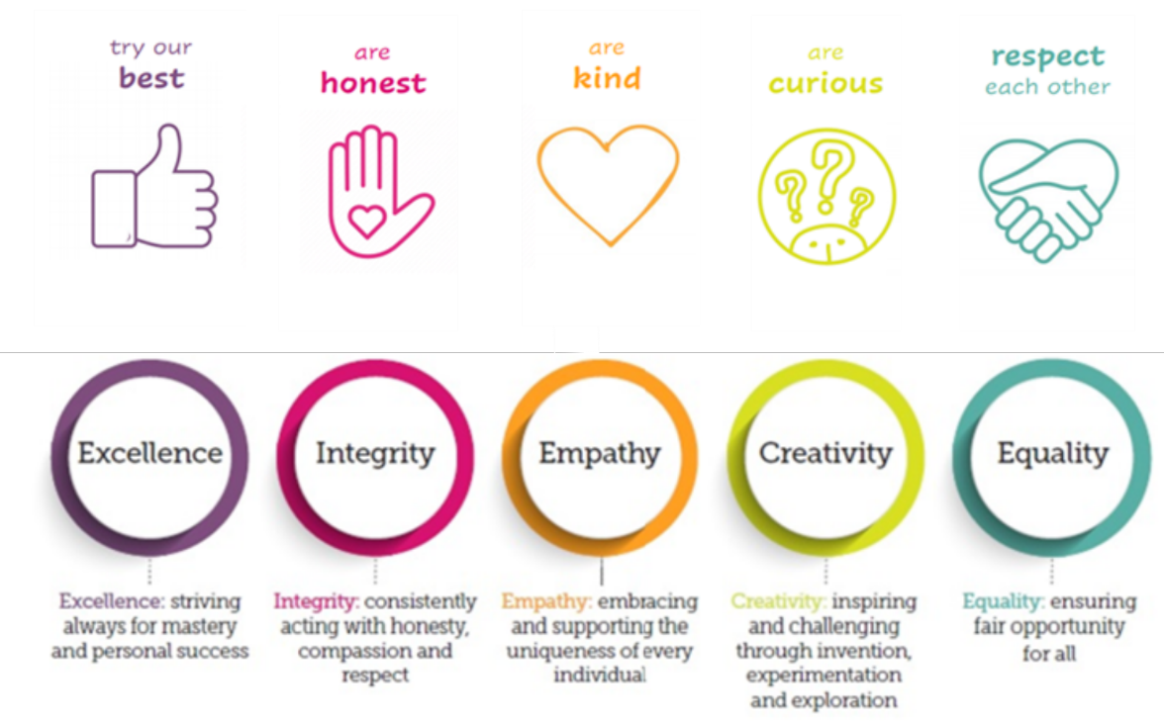
The Grange Primary welcomes all CYP and believes that those who come to the Grange are Grangers, and as Grangers, like the school mascot, Pip the owl, we dream big and fly high. This underpins the ethos of Grange, that all CYP at the Grange are valued, welcomed and given the best possible education to permit them to thrive in the world. Consequently, all our CYP’s needs are regarded as special and the needs of CYP with learning difficulties and/or disabilities (SEND) will be addressed naturally within the school’s learning policy, with those regarding additional or different support being catered for in our school. We work closely with parents/carers, the Local Authority, and other agencies, to provide the best provision for all our CYP through a child-centred approach.

Legislation and guidance
This policy and information report is based on the statutory Special Educational Needs and Disability (SEND) Code of Practice and the following legislation:
- Part 3 of the Children and Families Act 2014, which sets out schools’ responsibilities for CYPs with SEN and disabilities
- The Special Educational Needs and Disability Regulations 2014, which set out schools’ responsibilities for Education, Health and Care (EHC) Plans, SEND Coordinators (SENCos) and the SEND Information Report

WHAT IS A SPECIAL EDUCAtiONAL NEED AND DISABILITY (SEND)?
A CYP has SEND where their learning difficulty or disability calls for special educational provision. This means provision that is different from or additional to that which is normally available to CYP of the same age.
The Special Educational Needs and Disability Code of Practice 0-25 Year (2014) identifies CYPs’ SEND in four broad areas of need:
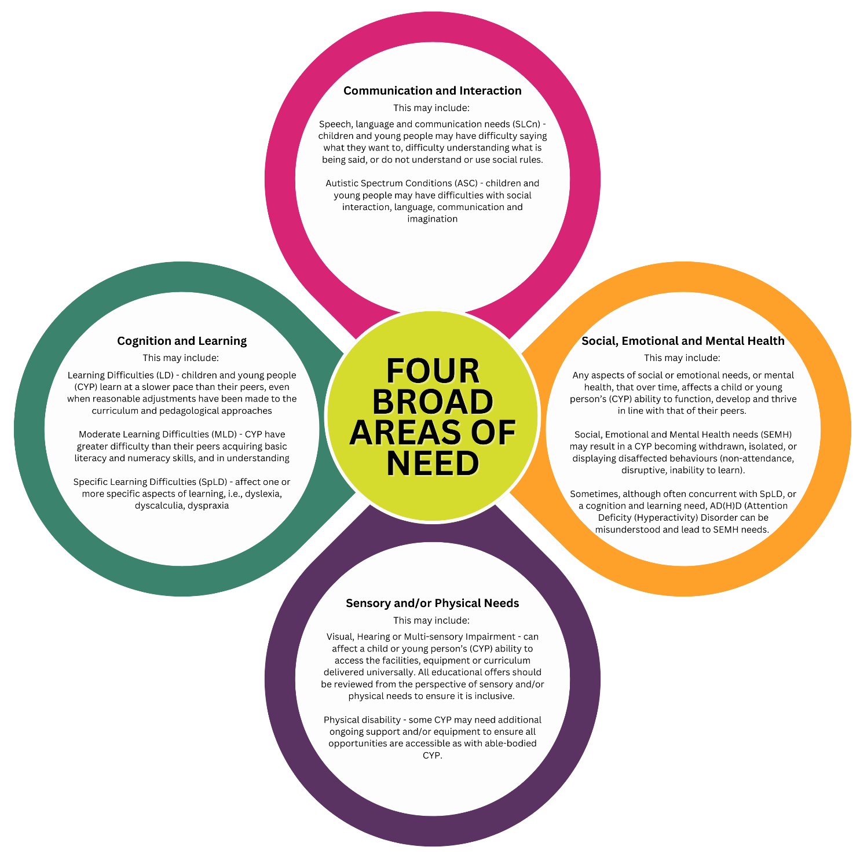

Who can I talk to about my cYP’s difficulties with learning/Special Educational Needs or Disability?
The Special Educational Needs and Disability Co-ordinator (SENDCo) for The Grange Primary School is:

 Mrs Jessica Rogers
Mrs Rogers is a qualified teacher and has completed the National Award for SEN Coordination (NASENCo), as required by the Children and Families Act 2014.

Please contact at:
Email: send@gra.mmat.co.uk
Tel: 01743 462984 to arrange an appointment.
Dojo: or via Dojo message

She is responsible for:
- coordinating all the support for CYP with special educational needs or disabilities (SEND) and developing the school’s SEND Policy and action plans to make sure all CYP get a consistent, high-quality response to meet their needs in school. This includes developing and monitoring the school’s graduated response of support for our SEND CYP and supporting the assessment of progress and impact.
- ensuring the changes under the SEND Code of Practice 2015 are implemented in line with the school’s SEND Development Plan.
- ensuring that parents/carers are involved in supporting their CYP’s learning, kept informed about the support their CYP is getting, and involved in reviewing how they are doing.
- liaising with all the other people who may be coming into school to help support a CYP’s learning e.g., Speech and Language Therapy, Educational Psychology, etc.
- updating the school’s SEND register (a system for ensuring all the needs of CYP with SEND in the school are known) and making sure that there are excellent records of your CYP’s progress and needs.
- providing specialist support for teachers and support staff in the school so they can help CYP with SEND in the school achieve the best progress possible.
- evaluating, in conjunction with all relevant stakeholders, the effectiveness of the school’s SEND provision.
- applying for additional support and funding where necessary for our most vulnerable student.
- coordinating teachers and Teaching Assistants to ensure the best support is given to the CYP on the SEND register and those with Graduated Support Plans and Education, Health and Care Plans.

Your CYP’s Class Teacher is responsible for:
- checking on the progress of a CYP with SEND and identifying, planning and delivering any additional help they may need (this could be things like targeted work, additional support) and letting the SENDCo know as necessary.
- writing Person Centred Plans (PCP), including an One Page Profile (OPP) and sharing and reviewing these with parents/carers at least once each term and planning for the next term.
- completing Assess, Plan, Do and Reviews of CYP’s targets.
- ensuring that all staff working with a particular CYP in school are helped to deliver the planned work/programme for the CYP, so they can achieve the best possible progress. This may involve the use of additional adults, outside specialist help and specially planned work and resources, in addition to differentiated Quality First Teaching.
- ensuring that the school’s SEND Policy is followed in all classrooms and for all the CYP they teach with SEND.
- implementing recommendations from outside agencies.

The Headteacher, Mrs Charlie Summers, is responsible for:
- the day-to-day management of all aspects of the school, this includes the support for CYP with SEND.
- giving responsibility to the SENDCo and Class Teachers, but is still responsible for ensuring that your CYP’s needs are met.
- making sure that the Governing Body is kept up to date about any issues in the school relating to SEND.
- support the school SENDCo in terms of budgeting the SEND provisions.

The SEND Governor, Julie Johnson, is responsible for:
- making sure that the necessary support is made for any CYP who attends the school who has SEND.
- challenging the school’s SEND department to ensure ALL CYP are supported to reach their full potential.

How can I let the school know I am concerned about my CYP’s progress in school?

How will the school let me know if they have any concerns about my CYP’s learning and progress?
Your CYP’s progress will be discussed with you at Parents’ Evening each term.
If it is felt that your CYP would benefit from being on the SEND Register, the school will set up a meeting with you to discuss this in further detail and to:
- listen to any concerns you may also have.
- plan any additional support for your CYP.
- discuss with you any referrals to outside professionals to support your CYP’s learning.

What are the different types of support available for CYP with SEND at The Grange primary SCHOOL?
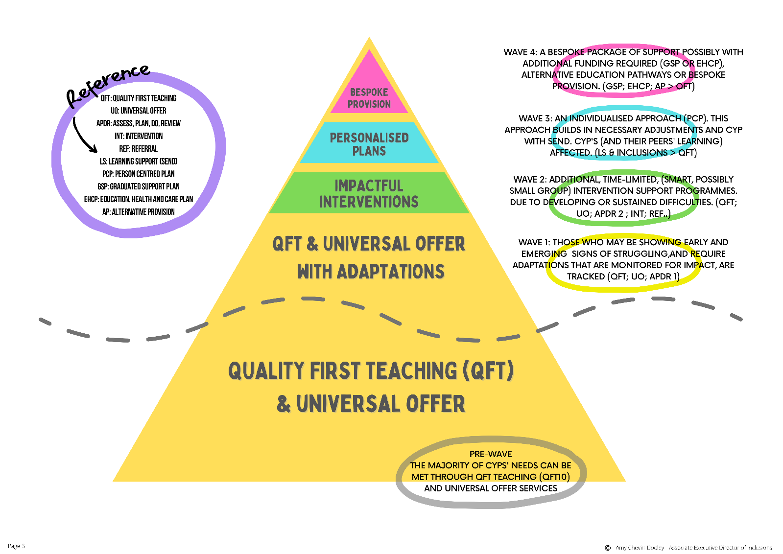
Support is provided along a graduated pathway at The Grange Primary School whereby the majority of CYPs’ needs are met through the Universal Offer, including Quality First Teaching. Where a CYPs’ needs are greater than the Universal Offer, an assessment of need will identify the appropriate next steps to support the CYP to a provision that meets their need: specific, low-level intervention, high-level intervention or an extensive provision, possibly with additional funding required, via a bespoke provision offer (Graduated Support Plan or Education, Health and Care Plan).

If my CYP requires an EHCP, how do I get this for my CYP?
Following intervention from both the school and outside agencies, it may be felt that your CYP’s needs are particularly complex and cannot be addressed from the budget available to the school. School (or you as a parent/carer) may wish to request that the Local Authority (LA) carry out a statutory assessment of your CYP’s needs. This is a legal process which sets out the amount of support that will be provided for your CYP.
For your CYP this will mean:
You and/or the school will complete a request for statutory assessment which will provide the LA with information about your CYP such as attainment levels, strategies and resources that have been used in school, areas of difficulty, external professionals’ advice and attendance.
The LA will then decide if your CYP’s needs seem complex enough to require a statutory assessment. If this is the case, they will then ask you and all professionals involved with your CYP to write a report outlining your CYP’s needs. If they do not think your CYP needs a statutory assessment, they will ask the school to continue with SEND Support.
After the reports have all been received by the LA they will decide if your CYP’s needs are severe, complex and lifelong and if additional support is required to enable your CYP to make good progress. If this is the case they will write an Education, Health and Care Plan (EHCP). If this is not the case, they will ask the school to continue with SEND Support.
The EHCP will outline the band of support your CYP will receive from the LA and how the support should be used and what strategies must be put in place to help your CYP meet long and short term goals. This support may be used to support your CYP with whole class learning, run individual programmes or run small group interventions to include your CYP.

How is extra support allocated to CYP and how do they move between the different levels?
- The school budget includes money for supporting CYP with SEND.
- The Headteacher decides on the budget for SEND in consultation with the School Governors and SENDCo, taking into account the CYP already receiving support, the CYP needing extra support and the CYP who have been identified as not making as much progress as would be expected.
- At The Grange, each class has an amount of Teaching Assistant or support staff (Teaching Assistant Apprentice) time to support CYP with SEND. The Class Teacher will organise the support staff time and target support according to the CYPs’ needs.
- If appropriate, CYP may also be part of targeted intervention groups to address particular needs.
- All resources and support are reviewed regularly, and changes made as needed.

WHo are the other people providing services to CYP with SEND at Grange?

What training do staff have to help them meet the needs of CYP with SEND?
- The SENDCo supports class teachers in planning for CYP with SEND.
- The Grange has a training plan for all staff to improve teaching and learning for all CYP and this includes whole school training on SEND issues such as ASD, speech and language difficulties, etc.
- Individual members of staff also attend training courses run by outside agencies that are relevant to the needs of specific CYP in their class.

How will teaching be adapted for my CYP with SEND?
- Class Teachers plan lessons taking into account the needs of all CYP in their class, including those with SEND.
- Specially trained Teaching Assistants can adapt the teacher’s planning further to meet the needs of individual CYPs, if needed.
- Your CYP may also be part of an intervention group to target a particular area of learning i.e., phonics or handwriting.
- If appropriate, particular resources may be provided to help your CYP’s learning i.e., writing slope, pencil grips, lap cushion, fidget toy.
- Planning and teaching will be adapted on a daily basis if needed to meet your CYP’s learning needs.

How do we evaluate the effectiveness of the provision made for CYP with SEND?
- All CYP, including CYP with SEND, have their progress and attainment tracked throughout the year. These assessments vary dependent on the CYP’s phase but may include NFER assessments in Reading, GAPS (Grammar and Punctuation, Spelling) and Maths, Read Write Inc. (RWI), class teacher assessments, Hodder Access Reading Test (ART), barriers to learning screeners, or Early Years and Foundation Stage (EYFS) assessments focusing on Communication and Literacy (CL), Personal, Social and Emotional Development (PSED), Physical Development (PD), Speech Communication or RBA.
- Pupil progress (WAVE) meetings are held regularly throughout the year to identify CYP, including those with SEND, that are not making expected progress and during these meetings it is agreed the support being put in place for these CYP.
- Targeted interventions are put into place for CYP who are not making expected progress and interventions are tracked and analysed to evaluate the impact.
- Regular meetings with staff, parents/carers and CYP ensure that interventions and additional support have the desired impact on CYPs’ progress, attainment, and personal development.

How are CYPS and young people with SEND facilitated to engage in activities available with CYPs in the school who do not have SEND?
- We ensure that all CYP have equal opportunities.
- All our CYP are encouraged to join in a large range of extra-curricular activities.
- We ensure that our school environment is adjusted and adapted to meet the specific needs of any individual student.

How do we support the emotional and social development of our CYP with SEND?
The wellbeing of all our CYP is paramount.
- Our SENDCo is a designated safeguard lead and works very closely with the other designated safeguard leads in school to ensure that all CYP are well supported in their wellbeing.
- Our PSHE curriculum supports the needs of all CYP including those with SEND.
- For those CYP with particular social and emotional needs, targeted intervention groups are made available. We also have an ELSA trained member of staff, and staff trained in No Worries CBT and Draw and Talk therapy, to support complex needs.
- At The Grange, we have qualified members of staff who support student with a range of emotional needs including recognising emotions, self-esteem, social skills, friendship skills, anger management, loss, and bereavement.
- Clear and consistent application of the Granger Code promotes positive behaviour and is used across school, and also promoted during assembly time. All staff, children and families are made aware of the Granger Code, and this is focused on addressing needs of learners to negate poor behaviour choices.

How will we measure the progress of your cYP in school?
- Their progress will be formally reviewed every term by the class teacher and given a level in reading, writing, grammar, punctuation, and spelling (GPS) and maths. In Nursery and Reception, progress will also be robustly tracked across all areas of the CYP’s development.
- Grange primary uses a variety of assessments to assess and monitor attainment and progress in CYP’s learning.
- At the end of each key stage (i.e., at the end of year 2 and year 6) all CYP are assessed using Standard Assessment Tests (SATS). This is something the government requires all schools to do and are the results that are published nationally. If the SATS are not appropriate for your child due to the level of their need, they may not have to sit them.
- CYP with SEND have a Pupil Centred Plan (PCP) which will be reviewed with you each term.
- CYP PCPs and assessment data are monitored by the SENDCo each term to ensure learning approaches are appropriate and CYP with SEND are making progress.
- If your CYP has an EHCP, this will be formally reviewed with you at an Annual Review with all adults involved in your child’s education.

How is grange accessible to CYP with SEND?
- Grange is all on one level, with ramps where necessary, which ensures it is accessible to all CYP.
- We also have toileting facilities for disabled users.
- We ensure that equipment used is accessible to all CYP regardless of their needs.
- After school clubs (including the wraparound care provision) and extracurricular activities are open to all CYP, including those with SEND.

How do we work together with CYP with SEND?
- We value the opinion of all our CYP and allow regular opportunities for CYP to discuss their learning. CYP are involved in peer and self-assessing regularly and respond to marking to improve their learning.
- SEND CYP PCPs are created and reviewed with the child termly.
- CYP participate where possible in setting targets.

What expertise are available within our school?
Teaching and Support staff have a vast range of skills, including:
- Mental Health First Aid practitioners
- Stoke Speaks Screener trained staff
- Nuffield Early Language Intervention Training
- Elkan - Speech & Language Support
- Range of NHS Speech and Language training course
- Read Write Inc. trained staff
- Precision Teaching trained staff
- ASD Training - Levels 1, 2 and 3
- Attachment Training – Levels 1, 2 and 3
- Supporting CYPs with Dyslexia
- Positive Handling trained staff
- Draw and Talk trained staff
- Play Therapy
- Lego Therapy
- Nurture training

Which external agencies do we work with?
We access a wide variety of services to support all aspects of development for SEND CYPs, including:
- Educational Psychologist Service
- Family Support Workers
- Sensory Inclusion Service
- Severe Speech Language Impairment Children’s Team – (SSLIC)
- Speech & Language Therapy Team (SALT)
- Young People and Families Mental Health Service (BeeU previously CAMHS)
- BEAM
- Occupational Therapy Services
- Reach for Inclusion
- Outreach Services
- SPECTRA
- Climb/Steps

How do we work together with you as a parent of a cyp with SEND?
- We believe that parent/carer involvement and support is vital to the success of the education of the CYP, and especially those with SEND.
- At The Grange, we have an open-door policy and class teachers are always available to discuss your CYP’s progress or any concerns you may have, at a mutually convenient time.
- The SENDCo is available to meet with you to discuss your CYP’s progress or any concerns/worries you may have. An appointment can be made through the school office.
- The SENDCo runs a drop-in session during parent’s evenings.
- Class Teachers will share with you, strategies that are working well in school for your CYP so that similar strategies can be used at home if appropriate.

We work closely with all parents/carers to listen to their views so that we can build on CYP previous experiences, knowledge, understanding and skills so that they develop in all aspects of the curriculum.
All parents/carers are encouraged to attend Parents’ Evening each term, as well as the 10-minute SEND meetings with the Class Teacher. During the SEND meetings your child’s SEND PCP and targets will be reviewed and updated together. Support and strategies will be discussed to support your child both at home and in school.
CYP who have an EHCP will also have an annual review. The CYP, parents/carers and professionals who are working with the CYP, will be invited to the meeting to review progress and set new challenging targets for the future.
All information from outside professionals will be discussed with you by the professional concerned, or where this is not possible, in a report.
Homework will be adjusted as appropriate to meet your CYP’s needs.
If appropriate, a home/school contact book may be set up to support communication between home and school.
We respect the differing needs of parents/carers such as disability or communication and linguistic barriers. Parents/carers are also encouraged to bring an appropriate friend/relative to meetings if they wish to do so.

SEND Local Authority –Local Offer
www.shropshire.gov.uk/the-send-local-offer/

Further support is available from The Shropshire Information, Advice and Support Service (Shropshire IASS) which provides free, confidential, and impartial information, advice and support regarding special educational needs and disabilities (SEND), including health and social care.
Contact Shropshire IASS on 01743 280019. The referral line is manned Monday to Friday, 10am till 4pm.
Email address: iass@shcab.cabnet.org.uk Website: http://www.cabshropshire.org.uk/shropshire-iass/

How will we support your child when they move to another class in our school or they leave grange?
We recognise that transitions can be difficult for all CYP and particularly CYP with SEND. We therefore take the following steps to ensure transition is as smooth as possible:
When your CYP moves to another class in our school we will;
- ensure teachers have a transition meeting before your child moves class, in order to pass on information such as CYP PCPs (including learning styles, outside agencies involved, particular interests); make a social story with your CYP, if appropriate to their needs, with details of staff and routines in the new class.
- Transition is bespoke to the individual child, so parents, teachers and the child work collaboratively to find a plan that best works for the CYP. We hope this will help to alleviate any anxieties and enables a relationship with the CYPs and teacher to form prior to the September start.
If your CYP moves to another school, we will:
- contact the SENDCo at the new school and ensure they are aware of the support your CYP needs.
- ensure that all records about your CYP are passed on as soon as possible.
In Year 6 we will:
- ensure the Year 6 teacher and SENDCo liaise with staff from the secondary school to pass on information.
- provide focused learning activities about aspects of transition to support your child’s understanding of the changes ahead.
- ensure your child has additional visits to their new secondary school.
- ensure the SENDCo from the appropriate secondary school is invited to your child’s Year 6 Annual Review.

WHat if i have a complaint about send provision?
We encourage open communication, but if concerns arise:
- Step 1: Speak to your child’s class teacher or SENDCo.
- Step 2: If unresolved, contact the Headteacher.
- Step 3: If still unresolved, follow our Complaints Policy (available on the school website or from the school office).
- Step 4: You can also contact the Local Authority or SENDIASS for further support.

Provision Map
 | All CYP have access to: | Additional strategies for CYP with SEND may include (when appropriate):
Cognition and Learning | - Quality first teaching  - Differentiation strategies  - Flexible teaching arrangements e.g., seating  - Stimulating curriculum  - Different learning styles  - Environment | - Focused teaching on individual targets  - In class TA support for English and Maths to focus on basic skills (small group or 1:1)  - Multi-sensory activities e.g., for spelling  - Extra ‘thinking time’ to organise thoughts and complete work  - Additional reading with an adult  - Additional use of ICT (information communication technology) for technology-assisted learning  - Speech to text software  - Visual timetables  - Scribe for writing  - Activities to develop memory skills  - Use of resources to focus concentration e.g., lap pads, fidget toys, privacy screens, ear defenders  - 1:1/small group teaching for phonics  - Individualised arrangements for SATs  - IDL programme  - Intervention groups  - Individual support from LSAT, Educational Psychologist and ASD Outreach service  - Precision Teaching

 | All CYP have access to: | Additional strategies for CYP with SEND may include (when appropriate):
Communication and Interaction | - Quality first teaching  - Differentiation strategies  - Flexible teaching arrangements e.g., seating  - Stimulating curriculum  - Different learning styles  - High focus on speaking and listening activities  - Language rich environment  - Use of Makaton within nursery | - Visual timetables  - Now and Next  - Multi-sensory activities  - Peer support to model language  - In class TA support for speech and language activities (small group or 1:1)  - Additional use of ICT (information communication technology) for technology-assisted learning  - Speech to text software  - Reader pens  - Visual timetables  - Use of barrier games  - Intervention groups e.g., social skills group, NELI  - Resources - tent, weighted lap rests etc  - Playground support  - Individual support from Speech and Language Therapist, LSAT or Educational Psychologist

 | All CYP have access to: | Additional strategies for CYP with SEND may include (when appropriate):
Social, Emotional and Mental Health | - Quality first teaching  - Differentiation strategies  - Flexible teaching arrangements e.g., seating  - Stimulating curriculum  - Calming learning environment  - Class visuals  - Different learning styles  - Whole school behaviour policy (Granger Rangers)  - Use of Dojos within class to recognise positive behaviour  - Zones of Regulation programme  - Whole school and class rules  - Focused PSHE curriculum  - High flyer awards and other strategies for recognition  - Positions of responsibility e.g., School Council | - Focused teaching on individual targets  - In class TA support and reminders  - Playground support  - Individualised reward systems – related to interests and personalised targets.  - Separate areas for independent work when appropriate  - Visual timetables  - Small group circle time  - Access to quiet ‘time out’ space  - Social stories and comic strip activities  - Regular contact with Inclusion Lead & Pastoral Team when identified.  - Regular meetings with school counsellor  - Intervention groups e.g. No Worries, Volcano in my Tummy, Zones of Regulation, social skills group, Socially Speaking, Talk About  - Behaviour Support Plans  - Mindfulness activities – breathing buddies  - Individual support from Woodlands Outreach, LSAT, Educational Psychologist, BeeU, ASD Outreach  - NEST Provision for SEMH support programme
 | All CYP have access to: | Additional strategies for CYP with SEND may include (when appropriate):
Sensory and Physical | - Quality first teaching  - Differentiation strategies  - Flexible teaching arrangements e.g., seating  - Stimulating curriculum  - Different learning styles  - Fine Motor Skill activity box  - PE curriculum  - Fit 15 daily  - After school sports clubs  - School games teams  - Forest School in Nursery, Reception and Year 1.  - Multi-sensory mark making activities for Nursery & Reception | - Focused teaching on individual targets  - In class TA support  - Use of resources such as pencil grips, writing slopes, different paper types, larger fonts, alternative PE equipment  - Visual timetables  - Additional use of ICT  - Forest School activities  - Intervention groups e.g., Cool Kids, Speed Up Handwriting, Motor Skills United, OT Pack, Jungle Journey (Nursery & Reception)  - Toilet for disabled users  - Hearing impairment equipment  - Individual support from Sensory Inclusion service, Occupational Therapy, Physiotherapy.

